

**MobiTel Application**

*Systems Requirements Specification Document for*

28 October 2013



**Systems Requirements Specification Document**

**09C1795 CETYIWE, SINAKO**

**10G0504 GARDNER, ASHLEY**

**09M3478 MABUZA, NONHLANHLA**

**10R1132 RABONDA, SHANA-MICHELLE**

**10R1465 REDDY, NICOLAN**

**09S2467 SOBEKWA, LWANDO**

|  |  |  |  |
| --- | --- | --- | --- |
| **Document** **History** | | | |
| **Date** | **Version #** | **Description** | **Changed by** |
| 10/05/2013 | 3.1 | 1st Outline | Nicolan Reddy |
| 12/05/2013 | 3.2 | Added context and class diagrams | Ashley Gardner |
| 15/05/2013 | 3.3 | Added activity diagrams and sequence diagrams | Nicolan Reddy |
| 20/05/2013 | 3.4 | Edited document | Ashley Gardner |
| 30/07/2013 | 3.5 | Edited context, class and use case diagram. | Nicolan Reddy |
| 06/08/2013 | 3.6 | Edited activity and sequence diagrams | Ashley Gardner |
| 12/08/2013 | 3.7 | Edited document | Nicolan Reddy |
| 13/08/2013 | 3.8 | Edited document and adding Testing provisions | Ashley Gardner |
| 15/08/2013 | 3.9 | Finalised document | Nicolan Reddy |
| 02/09/2013 | 3.10 | Added TeleWeaver information and new diagrams | Ashley Gardner |
| 05/09/2013 | 3.11 | Added new Use Case Diagram, Sequence Diagram, Activity Diagram | Nicolan Reddy |
| 06/09/2013 | 3.12 | Added Value Proposition mind map, TeleWeaver Context Diagram and TeleWeaver Use Case Diagram | Nicolan Reddy |
| 12/09/2013 | 3.13 | Added new activity diagrams, Changed UC diagram | Nicolan Reddy |
| 16/10/2013 | 4.1 | Final changes | Ashley Gardner  Nicolan Reddy |

**Contents**

1. Purpose of this document 6

1.1. Scope of the Application 6

1.2. Definitions, Acronyms, Abbreviations 7

1.2.1. Definitions 7

1.2.2. Acronyms 8

1.3. Conventions 8

1.4. Intended Audience 8

1.5. Business Context 9

1.6. Stakeholders 9

1.7. Analysis methodology to be used 10

1.8. Value Proposition 11

1.9. References 12

2. Overall Description of the Proposed System 13

2.1. Product Perspective 13

2.2. Product Architecture 13

2.3. TeleWeaver 13

2.4. Product Functionality/Features 14

2.5. User Characteristics 14

2.6. Constraints 14

2.7. Assumptions and Dependencies 15

3. State Specification 16

3.1. Class Diagram 16

4. Behaviour Specifications 17

4.1. Functional Requirements 17

4.1.1. Context Diagram 17

4.1.2. Use Case Diagram: MobiTel 19

4.1.3. Use Case Diagram: TeleWeaver 20

4.1.4. Use Case Narrative Specifications 21

4.1.5. Activity Diagram 32

4.1.6 Sequence Diagram 41

5. State Change Specifications 50

5.1. State Chart Diagram 50

5.1.1. Business Class 50

5.1.2. Accommodation Class 51

5.1.3. Room Class 52

5.1.4. Booking Class 53

6. Operational Requirements 54

6.1. Safety Requirements 54

6.2. Security and Privacy Requirements 54

6.3. Environmental Requirements 54

6.4. Interface Requirements 54

6.5. Performance Requirements 55

6.6. Operational Requirements 55

6.7. Software Quality Factors 56

6.7.1. Usability 56

6.7.2. Reliability 56

6.7.3. Availability 56

6.7.4. Maintainability 56

6.7.5. Portability 56

6.7.6. Interoperability 56

6.8. Packaging Requirements 57

6.9. Precedence and Criticality of Requirements 57

6.10. External Interface Requirements (If known) 57

7. Testing Provisions 58

7.1. Testing Rubric 58

7.1.1. Testing Rubric Iteration 2, 13/08/2013: 58

7.1.2. Testing Rubric Iteration 3, 08/09/2013: 60

7.1.3. Testing Rubric Final, 27/10/2013: 62

7.1.4. User testing: Iteration 3. 64

8. User training 65

8.1. Goals and objectives 65

8.2. Measure of Success 65

8.3. Benefits 65

8.4. Costs 65

8.5. Limitations 65

8.6. Procedure 66

# Purpose of this document

This is the Systems Requirements Specification document for the MobiTel Application Iteration 3. The purpose of the Systems Requirements Specifications (SRS) document is to record and keep track of the user requirements and provide a foundation for the design process for the application development. This document will address the overall description of the application, state specifications, behaviour specifications, state change specifications, operational requirements and testing provisions. The requirements cover the work corresponding to the MobiTel application.

## Scope of the Application

In order for Luminus Solutions to be able to create a mobile application, specific details are required i.e. business details, accommodation details and room details. The scope of the mobile application involves enabling and supporting entrepreneurship that will ultimately promote tourism in the Dwesa community. The application will allow members of the Dwesa community who have guest accommodation services (Bed & Breakfast, Homestay and Self-catering accommodation) to:

1. Enter and modify details about a business’s guest accommodation service(s) within the Dwesa community
2. Upload pictures of the business and it’s guest accommodation services
3. Transfer the business’s guest accommodation service(s) details, via Wi-Fi, to TeleWeaver’s website when the mobile phone comes within range of TeleWeaver.
4. Mobile device should receive a notification of a booking (SMS/Email).
5. Language package must be installed to enable the business owner to change the language (e.g. IsiXhosa, isiZulu and English).

*Sale settlements will happen when the service is rendered (physical site/location).

The business information must be uploaded via a mobile device using an Android operating system and will require access details from TeleWeaver. The business owner must be able to upload and modify images and information, respectively, regarding their accommodation services which will ultimately be uploaded onto a website, via TeleWeaver, where tourists can view accommodation services available in the Dwesa community. The application will operate on a mobile device with an android operating system where the business owner can download the application onto their mobile device and access the application using a username and password supplied by TeleWeaver.

The tourist will view the business’s accommodation service(s) on TeleWeaver and make a booking online (on the TeleWeaver website). TeleWeaver will send a notification to the guest accommodation business owner identifying him/her of a booking for the accommodation.

## Definitions, Acronyms, Abbreviations

The following is a list of commonly used definitions used throughout this document

### Definitions

**Table 1: Definitions**

|  |  |
| --- | --- |
| **Terminology** | **Definition** |
| Context Diagram | A diagram representing the system that represents the actors and they interact with the system and boundaries |
| Class Diagram | Describes the structure of the system by showing the classes, attributes, operations and relationships |
| Use Case Diagram | This defines the interactions between an actor and the system |
| Activity Diagram | Shows the flow of the activities in the system |
| Sequence Diagram | Shows the interaction of the processes and how they operate with one another |
| State chart Diagram | Describes the behaviour of the system and its states |
| Use Case Narrative | This describes the functions of the use cases present in the use case diagram use case diagram |
| Stakeholder | A person who interacts with or is affected by the system is affected or affected by the system |
| Business owner | The business owner is a person who owns a B&B business and wishes to upload business details about their B&B. |
| Business | A business owner can have a business that he/she runs with a chain of guest accommodation facilities. |
| Accommodation | A business owner can have numerous accommodation types (B&B’s, Home Stays and Self-catering facilities). |
| Room | A business owner’s guest accommodation can offer single and/or double rooms which can be booked by tourists. |
| TeleWeaver | And open source technology and service integration platform (an integrated enabler for rural telecenters and access nodes) |

### Acronyms

**Table 2: Acronyms**

|  |  |
| --- | --- |
| **Acronym** | **Augmentation** |
| KPI | Key Performance Indicator |
| GUI | Graphical User interface |
| UML | Unified Modelling Language |

## Conventions

The format of Luminus Solutions’ documents is simple. The page size is set at borderless A4. Main headings will be left-aligned in size 22 fonts, with sub-headings in size 18 fonts. The remainder of the document will be written using Times New Roman Font 12.

## Intended Audience

This Android application is being developed for Reed House Systems and is targeted at the peri-urban areas, specifically the Dwesa community. The individuals in the Dwesa community will be able to download and use the Android application with the prospects of attracting tourists and promoting tourism in the Dwesa community.

This document will be used by the designers as ground work for their Systems Design Specifications document, stakeholders who have interest in what the application will provide and future analysts who may want to improve the application.

## Business Context

The members of the Dwesa community have numerous guest accommodation services on offer however they are often ostracised. This is due to the fact that they are a part of a peri-urban community where the use of ICT is minimalistic.

Reed House Systems is attempting to bridge the digital divide by targeting business owners who offer guest accommodation services to the public. It was found that it is difficult for marginalized entrepreneurs to compete with larger, more established businesses in the area.

Reed House requested Luminus Solutions to work within the Siyakhula Living Footprint to help bridge the digital divide between the marginalised entrepreneurs and the more established businesses in the Dwesa Community Tourism Industry. Reed House System’s requested Luminus Solutions to develop a mobile application that will communicate with TeleWeaver to enable local accommodation business owners to upload/modify the full set or a subset of accommodation service(s) onto the TeleWeaver website. The accommodation services details will be stored on the mobile device and will be transferred to the TeleWeaver website via Wi-Fi where tourists can identify accommodation services in the area.

The tourist will be able to view the business’s accommodation service(s) and make a booking online on the TeleWeaver website. TeleWeaver will then send a notification to the guest accommodation business owner identifying him/her of a booking.

## Stakeholders

When a mobile application is being developed it is important to take note of the demands of various sources. These sources are mainly the customers, analyst and internal stakeholders. In terms of Luminus Solutions’ micro-tourism mobile application, the likely stakeholders will be:

* Reed House Systems, who the application is being developed for;
* The local residents residing in the Dwesa community who want to advertise their business. These residents (user of the application) have businesses in the form of guest accommodation (Home Stay and Bed & Breakfasts)
* The local municipality which will benefit from the increase in tourism

## Analysis methodology to be used

An object oriented analysis methodology will be used. This means that the application will be modelled as a group of interacting objects. By modelling the application using this methodology it will be possible for the stakeholders to understand the application’s requirements by assessing the application’s class, state and behaviour. The SCRUM method will also be used throughout the application development. SCRUM development is an iterative agile software development framework. It helps the team to manage and develop the application through iterations instead of stages of the systems development lifecycle.

## Value Proposition

## References

Satzinger, J., Jackson, R., and Burd, S. (2009). **Systems Analysis and Design in a Changing World (5e).** Course Technology.

Reed House Systems, JAD Session from 26/04/2013, Rhodes University, Grahamstown.

Reed House Systems, JAD Session from 29/04/2013, Rhodes University, Grahamstown.

Reed House Systems, 2011. TeleWeaver [Online]. Available at: <http://reedhousesystems.com/?q=teleweaver> [Accessed 2 September 2013].

# Overall Description of the Proposed System

## Product Perspective

The purpose of the Luminus Solutions’ Android application is to promote entrepreneurship and leverage the skills available in marginalised rural and peri-urban areas in South Africa, specifically the Dwesa community, through the development of a front-end mobile application for micro tourism. This application will store local tourism information, specifically accommodation. The application must be accessible on an Android platform. A password will be required by the user(s) who is already registered on TeleWeaver in order to ensure that only the users have editing access to the application.

## Product Architecture

The product architecture consists of a presentation layer which deals with a graphical user interface that the user interacts with. The product also has a database layer where data is stored temporarily. The data will be uploaded onto a website when the mobile phone comes into TeleWeaver’s range. Hence, the application should be able to access Teleweaver via Wi-Fi.

## TeleWeaver

TeleWeaver is an integrated enabler for rural telecenters and access nodes. TeleWeaver was built by Reed House Systems in order provide Internet to rural areas and was built specifically for areas with limited resources in terms of hardware and software. Reed House Systems therefore ensured that TeleWeaver uses a mobile middleware technology as a basis, which will enable it to run on Java-enabled cellphones. TeleWeaver offers blueprints for services, which enables you to add your own resources to the network through open web services interfaces (Reed House Systems, 2011: 01). This is therefore what makes it possible for business owners to run our application on their cellphones and sync the information from the application with TeleWeaver.

The purpose of our mobile application, MobiTel, is for business owners in the Dwesa Community to manage the business information on the mobile application and sync their information with TeleWeaver when they are in range and the information will then be sent to TeleWeaver and stored in the database. This information will then be posted to TeleWeaver’s website to make the information available to the public. This can be seen in the Figure 1 below where MobiTel sends the information to TeleWeaver through restful web services which is then stored in TeleWeaver’s database.

TeleWeaver is therefore just a mechanism allowing for MobiTel to easily communication with TeleWeaver’s tourism website.

**Figure 1: MobiTel’s Communication with TeleWeaver**

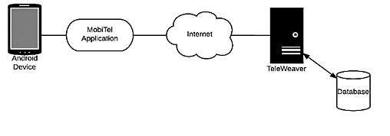

## Product Functionality/Features

* This application’s main function is to provide a simple, streamlined and an easy-to-use tool for members of the Dwesa community who wish to use the application to upload their business accommodation service(s) information, pictures, descriptions, prices and contact details.

## User Characteristics

* The business owners are aged between 18-65 years whose primary language is isiXhosa.
* The user of the application may have a high school level of education; however, their experience with android mobile applications may vary from none to some.
* Their motivation to use the android application is to leverage their skills and promote entrepreneurship.
* Hence, the application needs to be simple enough for basic cell phone users to easily understand how to use it.

## Constraints

* The network in the area might be poor and therefore the users will have to wait until they are in range of Wi-Fi connection to connect with TeleWeaver in order for their information to upload onto the website.
* The user is allowed to upload a maximum of 1 photo of their business.
* The user is allowed to upload a maximum of 3 photos of their room(s) and Accommodation(s).
* The application is unstable on different android versions.

## Assumptions and Dependencies

It is assumed that the business owners in the Dwesa Community are already registered with TeleWeaver in order for them to have administrative rights to the application. We also need to assume that the business owners have android devices and know how to use them. This application is dependent on TeleWeaver because the business owners need to be in range of TeleWeaver in order to transfer, via Wi-Fi, the full set of guest accommodation offers onto the TeleWeaver website.

# 

# State Specification

## Class Diagram

Has a

Belongs to

Belongs to

Offers

Associated with

Has a

*Out of Scope: Booking Class and Room Booking Class

# Behaviour Specifications

## Functional Requirements

### Context Diagram

4.1.1.1 MobiTel Application

Business owner

Booking Notification

Business Details

Business owner

TeleWeaver & Business owner

Business Details

Accommodation Details

Room Details Accommodation Details

Room Details

Business, Accommodation and Room Images

Business, Accommodation and Room Images

Login Details

Booking Reservation

Validated Login Details

TeleWeaver

TeleWeaver

**\*Out of Scope: Booking Reservation and Booking Notification**

4.1.1.2 TeleWeaver

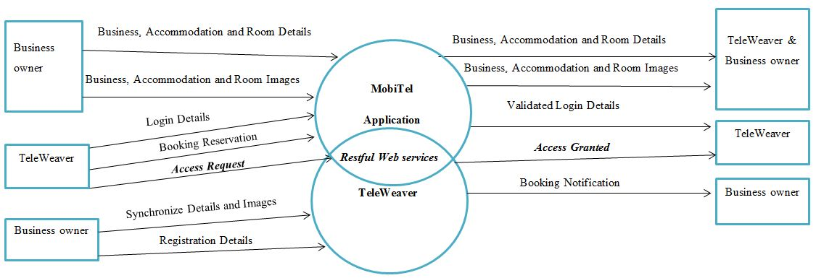

### Use Case Diagram: MobiTel

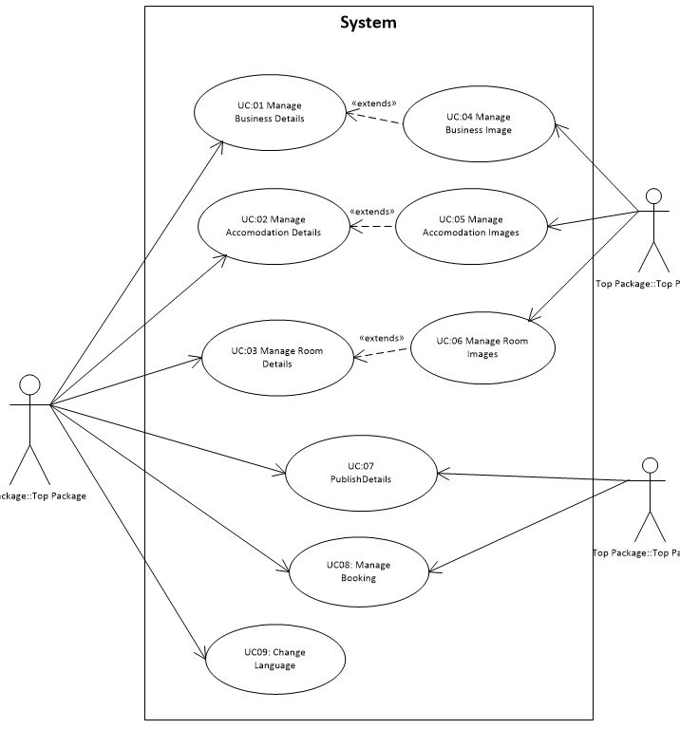

A01: Business owner

A02: TeleWeaver

A01: Business owner

**\*Out of Scope: UC08**

### Use Case Diagram: TeleWeaver

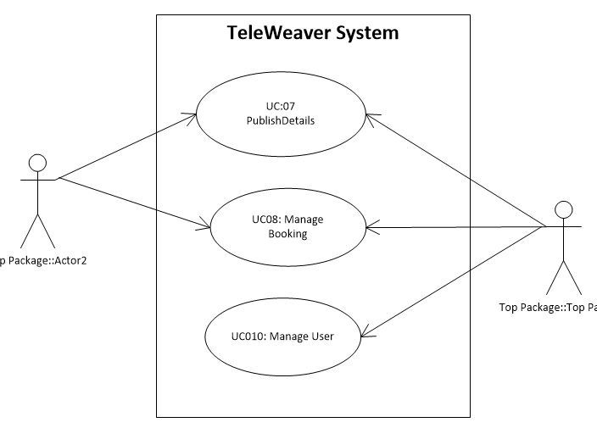

A01: Business owner

A02: TeleWeaver

*Out of Scope: Use Case Diagram illustrating TeleWeaver’s role in managing booking, managing users (TeleWeaver’s clients) and publish details.

### Use Case Narrative Specifications

4.1.4.1 UC01: Manage Business Details

|  |  |
| --- | --- |
| **Use Case** | **UC01: Manage Business Details** |
| Brief description | The business owner will add details about the business (name, description, address and contact details). |
| Actors | Business owner |
| Preconditions | The Business owner is registered on TeleWeaver.  The Business owner is known to the MobiTel Application. |
| Main flow | 1. The business owner identifies the need to add details about their business. 2. The relevant details are added into the MobiTel Application by the business owner. 3. The business owner identifies the need to remove details about their business. 4. The business is flagged onto the database as unavailable. 5. The business owner identifies the need to edit details about their business. 6. The relevant details are updated into the MobiTel Application. |
| Post conditions | The details are saved onto the MobiTel Application and will update their business information on the TeleWeaver website once the business owner comes into a Wi-Fi hotspot. |

4.1.4.2 UC02: Manage Accommodation Details

|  |  |
| --- | --- |
| **Use Case** | **UC02: Manage Accommodation Details** |
| Brief description | The business owner will add details about the accommodation (name, pictures, description, and location). |
| Actors | Business owner |
| Preconditions | The Business owner is registered on TeleWeaver.  The Business owner is known to the MobiTel Application. |
| Main flow | 1. The business owner identifies the need to add details about their accommodation. 2. The relevant details are added into the MobiTel Application. 3. The business owner identifies the need to remove details about their accommodation. 4. The business is flagged onto the database as unavailable. 5. The business owner identifies the need to edit details about their accommodation. 6. The relevant details are updated into the MobiTel Application. |
| Post conditions | The details are saved onto the MobiTel Application and will update their accommodation information on the TeleWeaver website once the business owner comes into a Wi-Fi hotspot. |

* + - 1. UC03: Manage Room Details

|  |  |
| --- | --- |
| **Use Case** | **UC03: Manage Room Details** |
| Brief description | The business owner will add details about the different rooms available (pictures, price and room type). |
| Actors | Business owner |
| Preconditions | The Business owner is registered on TeleWeaver.  The Business owner is known to the MobiTel Application. |
| Main flow | 1. The business owner identifies the need to add details about the different rooms they offer. 2. The relevant details are added into the MobiTel Application. 3. The business owner identifies the need to remove details about their rooms. 4. The business is flagged onto the database as unavailable. 5. The business owner identifies the need to edit details about their rooms. 6. The relevant details are updated into the MobiTel Application. |
| Post conditions | The details are saved onto the MobiTel Application and will update their room information on the TeleWeaver website once the business owner comes into a Wi-Fi hotspot. |

4.1.4.4 UC04: Manage Business Image

|  |  |
| --- | --- |
| **Use Case** | **UC04: Manage Business Image** |
| Brief description | The business owner will upload, remove or change the photo of their business. |
| Actors | Business owner |
| Preconditions | The Business owner is registered on TeleWeaver.  The Business owner is known to the MobiTel Application.  A business profile needs to exist. |
| Constraint | The business owner is allowed to upload only 1 photo of their business. |
| Main flow | 1. The business owner identifies the need to add a photo of their business. 2. The relevant photo is added into the MobiTel Application. 3. The business owner identifies the need to remove old/outdated photos of their business. 4. The image is flagged onto the database as unavailable. 5. The business owner identifies the need to update the photo of their business. 6. The relevant image is uploaded into the MobiTel Application. |
| Post conditions | The details are saved onto the MobiTel Application and will update their business image on the TeleWeaver website once the business owner comes into a Wi-Fi hotspot. |

4.1.4.5. UC05: Manage Accommodation Images

|  |  |
| --- | --- |
| **Use Case** | **UC05: Manage Accommodation Images** |
| Brief description | The business owner will upload, remove or change the photo(s) of their accommodation. |
| Actors | Business owner |
| Preconditions | The Business owner is registered on TeleWeaver.  The Business owner is known to the MobiTel Application.  A business profile and accommodation profile needs to exist. |
| Constraints | The business owner is allowed to upload a maximum of 3 photos of their Accommodation(s). |
| Main flow | 1. The business owner identifies the need to add photo(s) of their accommodation. 2. The relevant photo(s) are added into the MobiTel Application. 3. The business owner identifies the need to remove old/outdated photo(s) of their accommodation. 4. The image(s) is flagged onto the database as unavailable. 5. The business owner identifies the need to update the photo(s) of their accommodation. 6. The relevant image(s) is uploaded into the MobiTel Application. |
| Post conditions | The details are saved onto the MobiTel Application and will update their accommodation image(s) on the TeleWeaver website once the business owner comes into a Wi-Fi hotspot. |

4.1.4.6. UC06: Manage Room Images

|  |  |
| --- | --- |
| **Use Case** | **UC06: Manage Room Images** |
| Brief description | The business owner will upload, remove or change the photo(s) of their room. |
| Actors | Business owner |
| Preconditions | The Business owner is registered on TeleWeaver.  The Business owner is known to the MobiTel Application.  A business profile, accommodation profile and room profile needs to exist. |
| Constraints | The business owner is allowed to upload a maximum of 3 photos of their room(s). |
| Main flow | 1. The business owner identifies the need to add photo(s) of their room. 2. The relevant photo(s) are added into the MobiTel Application. 3. The business owner identifies the need to remove old/outdated photo(s) of their room. 4. The image(s) is flagged onto the database as unavailable. 5. The business owner identifies the need to update the photo(s) of their room.   The relevant image(s) is uploaded into the MobiTel Application. |
| Post conditions | The details are saved onto the MobiTel Application and will update their room image(s) on the TeleWeaver website once the business owner comes into a Wi-Fi hotspot. |

4.1.4.7. UC07: Publish Details

|  |  |
| --- | --- |
| **Use Case** | **UC07: Publish details** |
| Brief description | The business owner will upload the photo(s) of their business, accommodation and room(s) onto TeleWeaver website. |
| Actors | Business owner |
| Preconditions | The Business owner is registered on TeleWeaver.  The Business owner is known to the MobiTel Application.  A business profile needs to exist.  A Wi-Fi signal/internet connection needs to be established. |
| Main flow | 1. The business owner identifies the need to synchronise all the business, accommodation and room details and photos with TeleWeaver. 2. A connection with TeleWeaver is verified. 3. The relevant business, accommodation and room details and image(s) are uploaded onto the TeleWeaver |
| Post conditions | The details are saved onto the in the TeleWeaver database and will be available on the TeleWeaver website. |

4.1.4.8. UC08: Manage Booking

|  |  |
| --- | --- |
| **Use Case** | **UC08: Manage Booking** |
| Brief description | The business owner will receive a notification on their mobile device of a booking reservation(s) made by their guest(s) where the business owner will only be able to view the booking(s) made by guests on their mobile device. The notification will contain guest contact details and booking dates. The business owner will contact the guests to confirm the booking. |
| Actors | Business owner |
| Preconditions | The Business owner is registered on TeleWeaver.  The Business owner is known to the MobiTel Application.  A business profile needs to exist.  A Wi-Fi signal/internet connection needs to be established. |
| Main flow | 1. The business owner receives booking notification(s) on their mobile device. 2. The business owner identifies the need to view booking notification(s). 3. The business owner checks availability of room(s) 4. The business owner reserves the room(s) 5. The business owner contacts the guest for confirmation of booking 6. The business owner books the room(s). |
| Post conditions | The accommodation is booked for the customer. |

**\*Out of scope**

4.1.4.9 AC01: Business owner

|  |  |
| --- | --- |
| **Actor** | **AC01: Business owner** |
| Brief description | The business owner will manage details about their business, accommodation and rooms. |
| Actors | Business owner |
| Preconditions | The Business owner is registered on TeleWeaver.  The business owner is known to the MobiTel Application. |
| Main flow | 1. The business owner identifies the need to add, edit or remove business, accommodation and/or room details and images. 2. The relevant details/images are entered into or removed from the application. 3. When the business owner and device are within range of TeleWeaver, the business, accommodation and room details and images should be uploaded onto TeleWeaver. |
| Alternative flow | N/A |
| Post conditions | The updated accommodation details were saved into the application and will update TeleWeaver when the business owner comes into the signal range of a Wi-Fi hotspot. |

* + - 1. AC02: TeleWeaver

|  |  |
| --- | --- |
| **Actor** | **AC02: TeleWeaver** |
| Brief description | TeleWeaver will emit a Wi-Fi signal to enable business owners to connect and synchronise their business, accommodation and room details and images with the TeleWeaver website. In addition, TeleWeaver sends a notification to the mobile device notifying the business owner of a booking. |
| Actors | TeleWeaver |
| Preconditions | TeleWeaver must emit a Wi-Fi signal.  The business owner is known to the MobiTel Application. |
| Main flow | 1. TeleWeaver identifies the need to add the information provided by MobiTel to their system and publish it on their tourism website. |
| Alternative flow | N/A |
| Post conditions | TeleWeaver must save the business, accommodation and room details and images on their database. |

4.1.4.11 UC09: Change Language

|  |  |
| --- | --- |
| **Use Case** | **UC09: Change Language** |
| Brief description | The business owner has the option to select from two different language options to help the business owner understand how to use the MobiTel Application in a language that the business owner is familiar with and can understand. |
| Actors | Business owner |
| Preconditions | The Business owner is known to the MobiTel Application. |
| Main flow | 1. The business owner recognises the need to change the language of the application to help them to understand how to use the application. 2. The business owner can select from a list of language options (English and isiXhosa). 3. The language throughout the application changes to the respective/selected language. 4. The business owner saves their choice of language. |

### Activity Diagram

#### Use Case 01: Manage Business Details

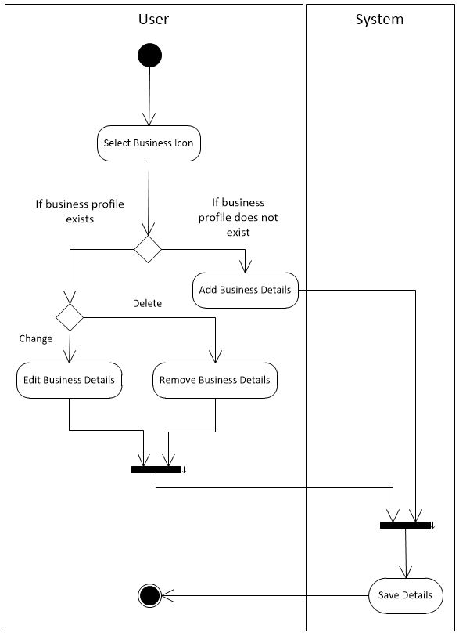

#### Use Case 02: Manage Accommodation Details

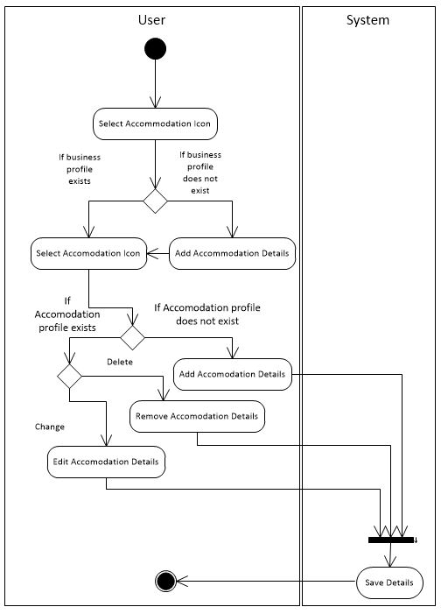

#### Use Case 03: Manage Room Details

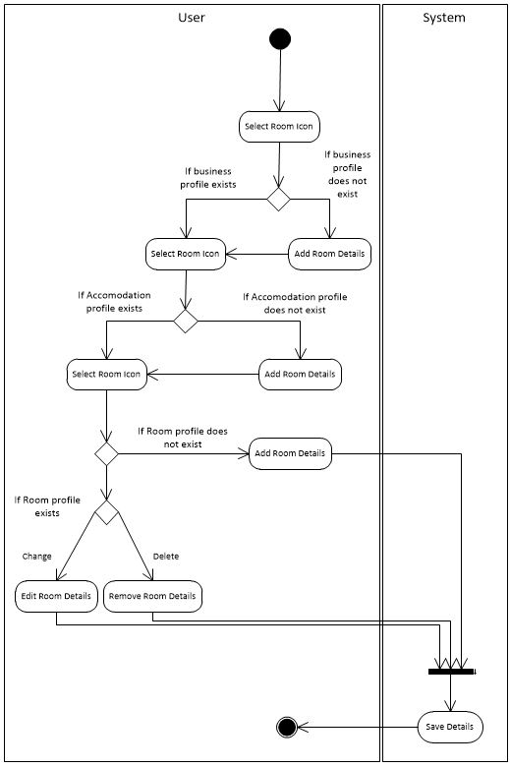

#### Use Case 04: Manage Business Image

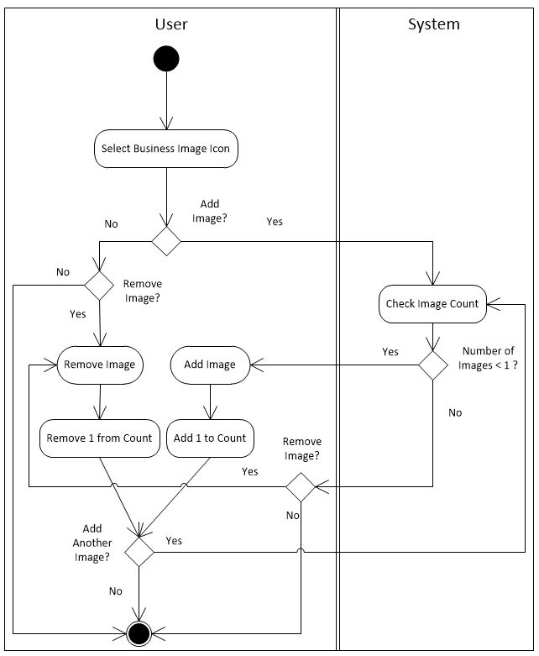

#### Use Case 05: Manage Accommodation Images

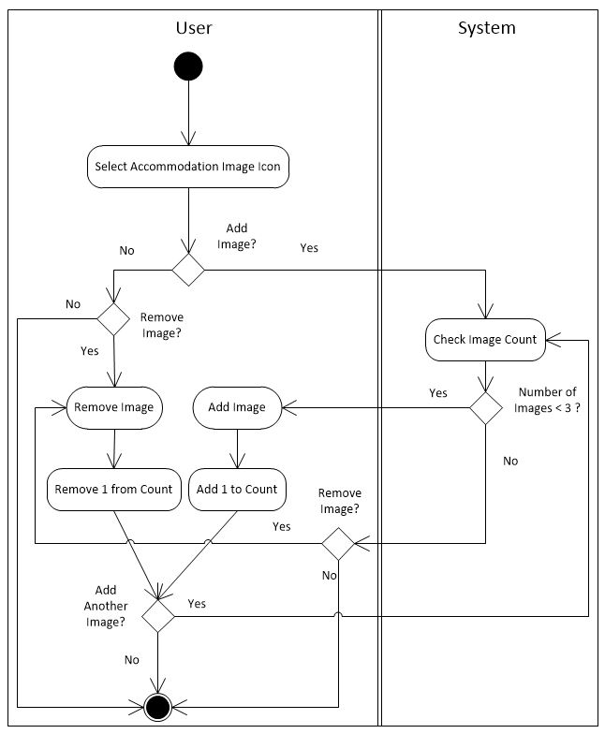

#### Use Case 06: Manage Room Images

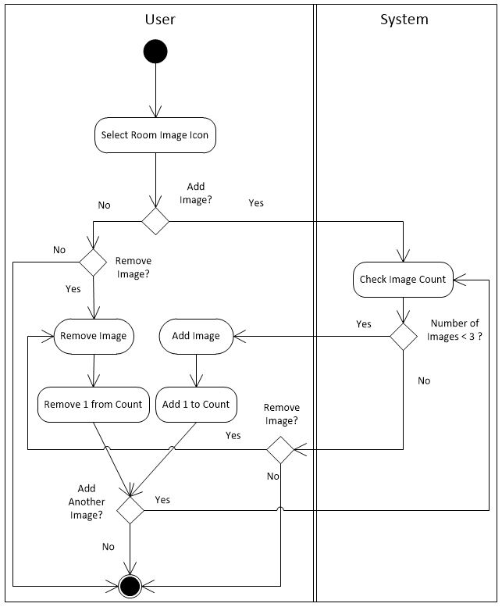

#### Use Case 07: Publish Details

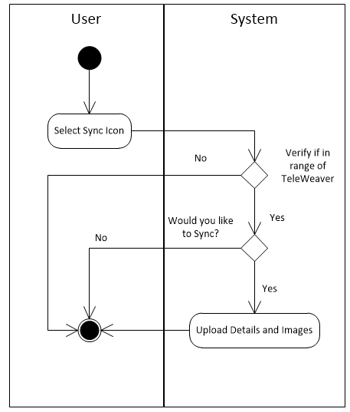

#### Use Case 08: Manage Booking

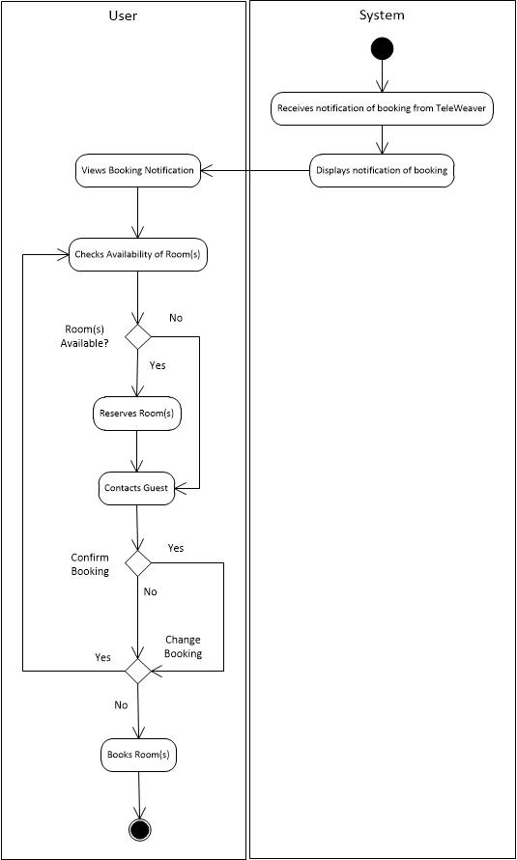

**\*Out of scope**

4.1.4.9 Use Case 09: Language Package Translation

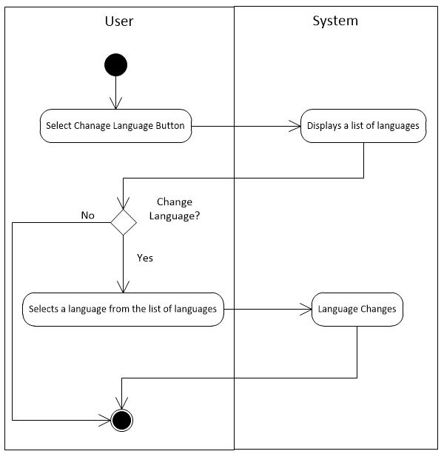

### Sequence Diagram

#### 

#### Use Case 01: Manage Business Details

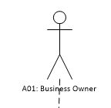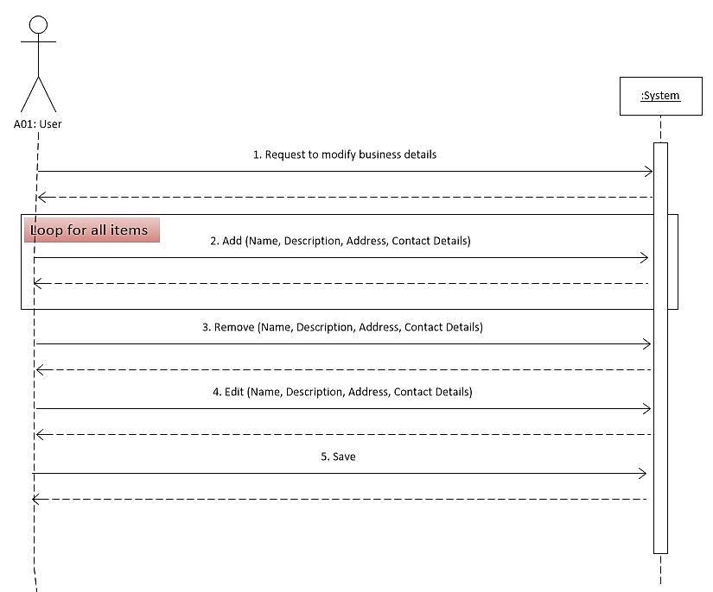

#### Use Case 02: Manage Accommodation Details

 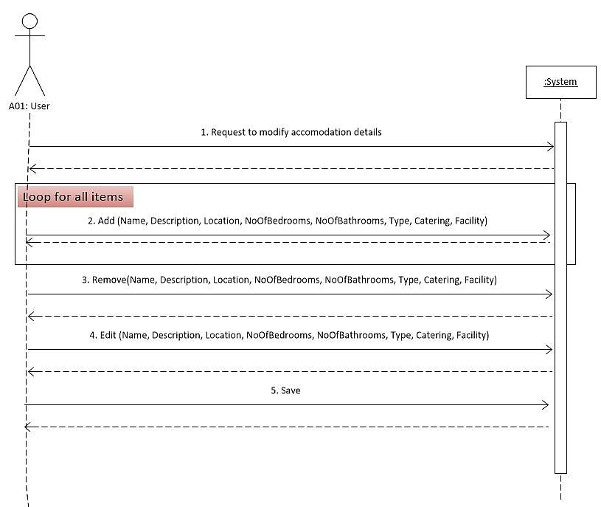

#### Use Case 03: Manage Room Details



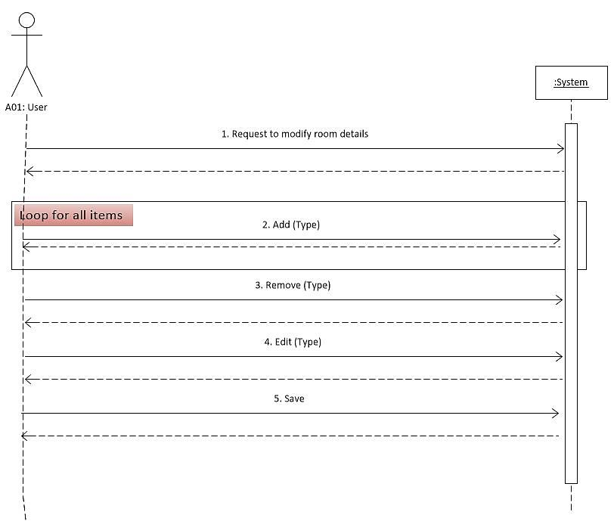

#### Use Case 04: Manage Business Image

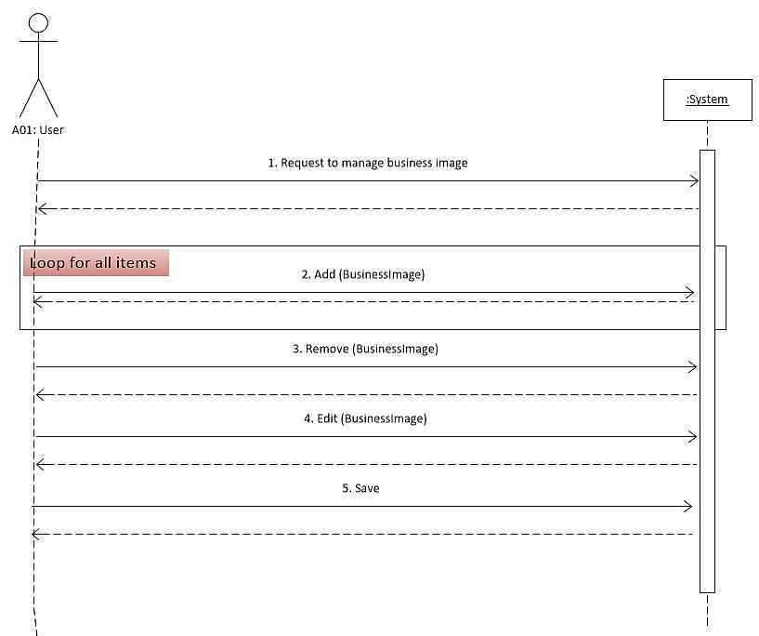

#### Use Case 05: Manage Accommodation Images

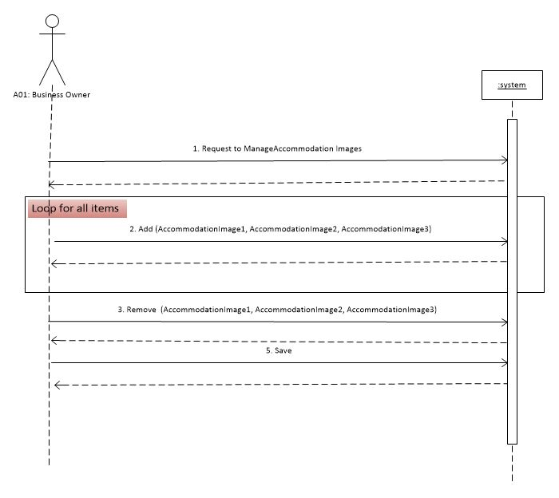

#### Use Case 06: Manage Room Images

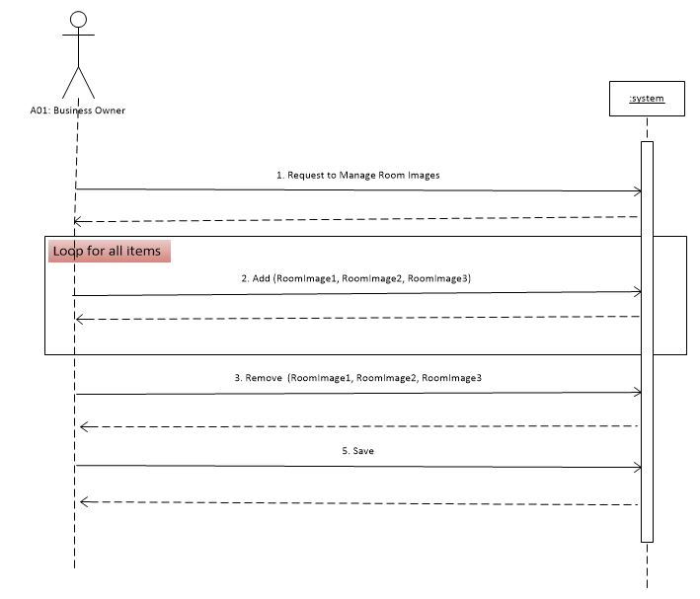

#### Use Case 07: Publish Details

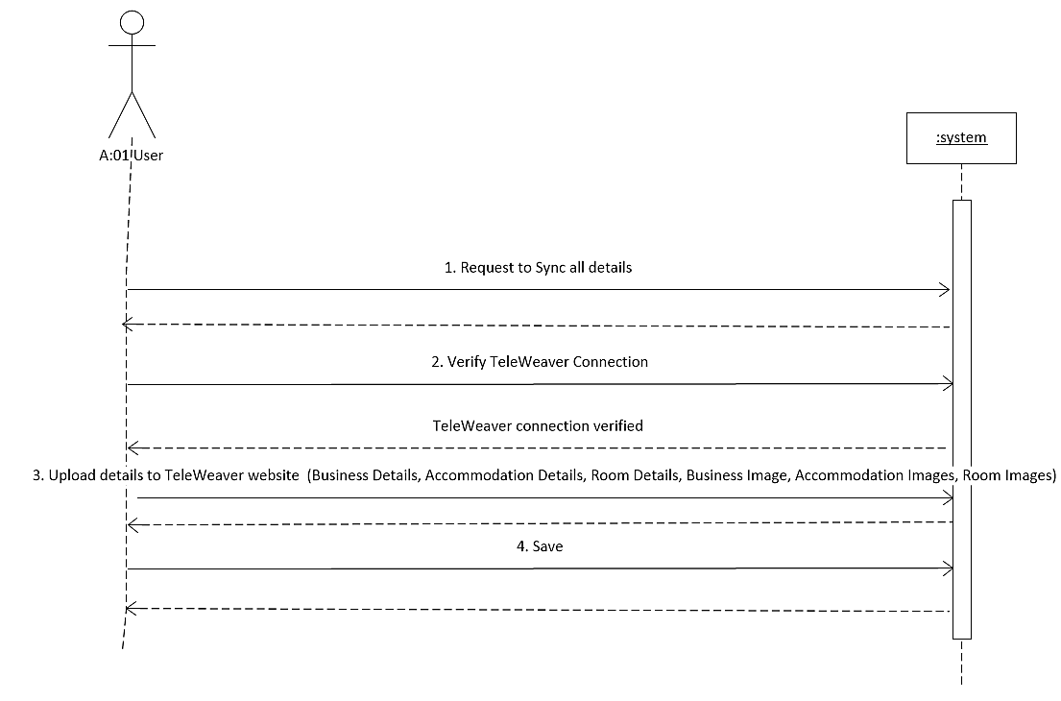

#### Use Case 08: Manage Booking

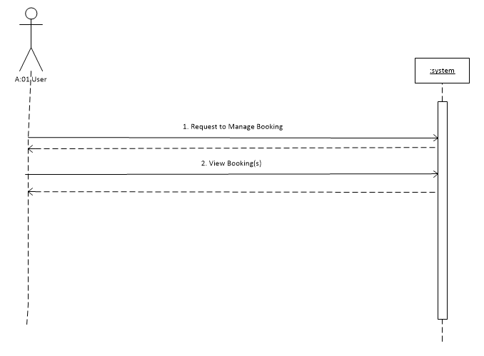

**\*Out of scope**

4.1.5.9 Use Case 09: Language Package Translation

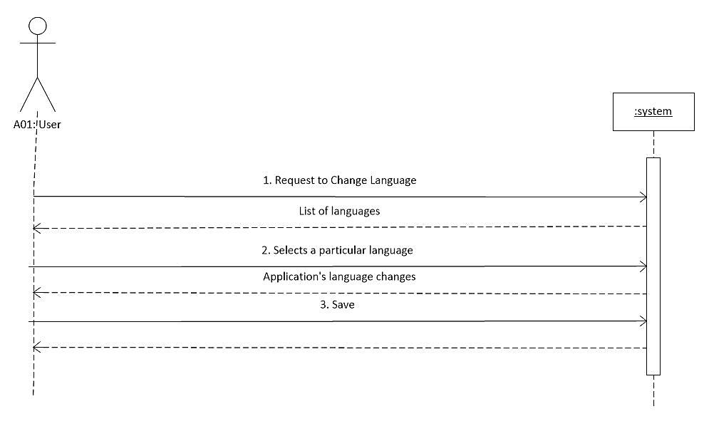

# State Change Specifications

## State Chart Diagram

### Business Class

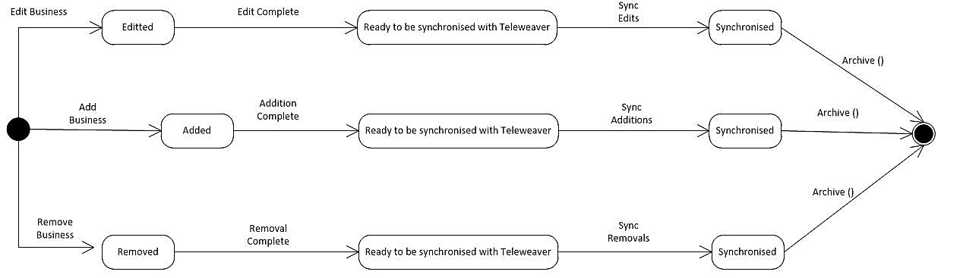

### Accommodation Class

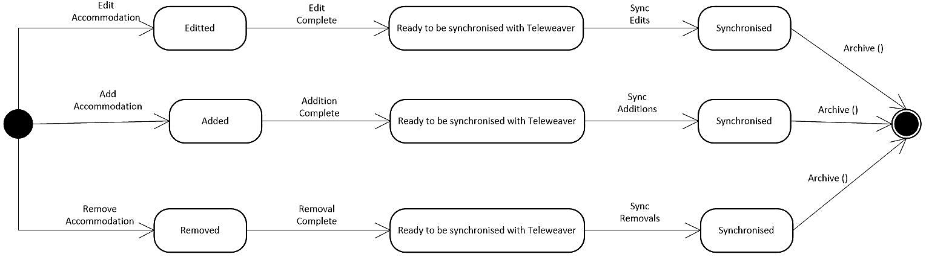

### Room Class

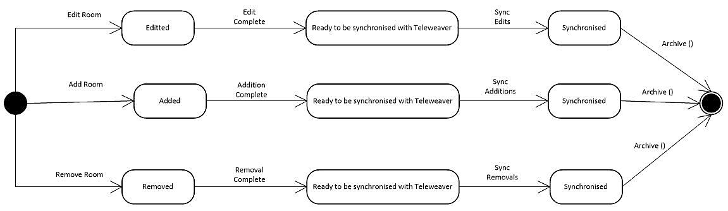

### Booking Class

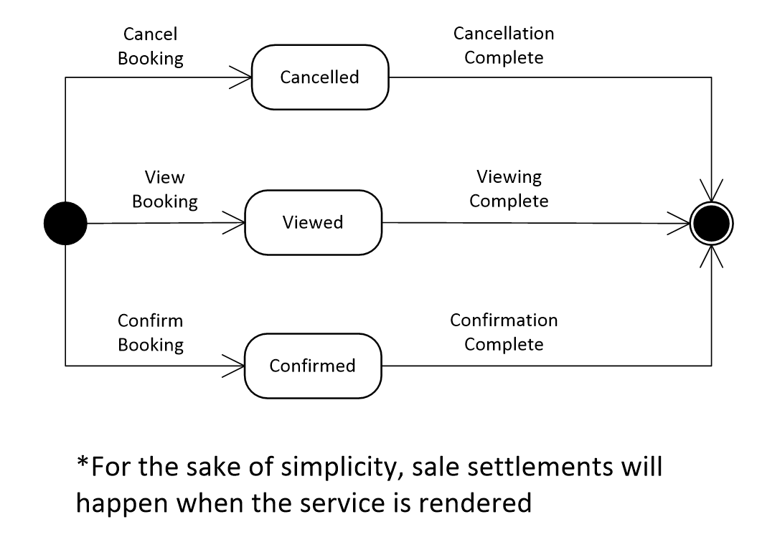

*Out of scope: Booking

*For the sake of simplicity, sale settlements will happen when the service is rendered

# Operational Requirements

## Safety Requirements

The application is subject to hazards of using a mobile device as per mobile device manual. No other safety requirements have been identified. The database containing information that has been uploaded by the business owner of the application will be backed up and secured separately by Reed House Systems.

## Security and Privacy Requirements

The TeleWeaver system will provide authentication details to the user (i.e. a username and password). These authentication details will be used to access the system. The application will synchronise with TeleWeaver in order to update information that has been uploaded onto the application by the user. The information that is being synchronized will be secured by TeleWeaver. The mobile application will not disclose personal information of TeleWeaver users, and will not collect any personal information from its own users. Administrative rights (to modify application data) are reserved for users with a TeleWeaver account.

## Environmental Requirements

The application should be able to take sync data with TeleWeaver systems via automatic conversion through a Wi-Fi connection. The application’s functionality is reliant on Android 2.3+ operating system features. The mobile device that will be running the application must be kept in a cool, dry environment.

## Interface Requirements

The Graphical User Interface (GUI) will be provided in a format that will allow the user to easily navigate around the system and access the data. The interface will consist of different windows and navigational controls, which are easily accessible and will enable the user to log in, manage their business, room and accommodation details and upload respective images.

## Performance Requirements

The application will need minimal hardware requirements to operate. The user interface is simple and will not require any heavy processing or graphics to run smoothly. Due to the application being able to host multiple users at any given time, it is recommended a higher level technological specifications being used with the system for optimized speed and efficiency of the program.

## Operational Requirements

**Table 3: Computer Hardware and Application Resource Utilization Requirements**

|  |  |
| --- | --- |
| **Computer Hardware Requirements** | |
| Central Processing Unit (CPU) | Android OS Gingerbread  832 MHz ARM 11 |
| Random Access Memory (RAM) | 512MB |
| **Computer Software Requirements** | |
| Android 2.3–2.3.2 Gingerbread (API level 9) Operating System | |
| **Computer Communication Requirements** | |
| The mobile phone running the application must have an active internet connection (WAP, GPRS or 3G). | |
| Memory | 512MB |
| Hard Disk (Storage) | 2 GB internal disk space available |
| Display | 3.2 inches (81 mm) 800x480 WVGA |

## Software Quality Factors

### Usability

The user interface will be designed to be visually appealing and easy for the user to navigate and use. Measures will be put in place for error prevention and error reporting through visual cues.

### Reliability

The application will meet all of the functional requirements and perform the required functions at the required time. The application will inform the user of any errors or unexpected behaviour.

### Availability

The application will be accessible at all times on the user’s Android device, given that the device is functioning properly. The user will be able to synchronize data that they have updated on the application with the data on the website when the mobile phone comes within range of TeleWeaver and encounters a Wi-Fi hotspot.

### Maintainability

The application code will be written clearly and concisely. The code will be well documented and written modularly for ease of updates and maintenance.

### Portability

This application will be designed to run on any Android operating system version 2.3 (Gingerbread) and forward compatible up to 4.2 (Jelly Bean). The application should not take up too much space or slow the users’ device by overusing device resources.

### Interoperability

The software code should allow for easy integration with TeleWeaver. Software should be also written for easy conversion to other mobile application platforms, albeit this is not in the scope of this project.

## Packaging Requirements

This application will be uploaded on to TeleWeaver’s website and will be available for download from there.

## Precedence and Criticality of Requirements

The following table depicts the mapping of the requirements, their corresponding precedence and criticality code. The precedence and criticality codes are:

* Essential (E)
* Desirable (D)
* Optional (O)

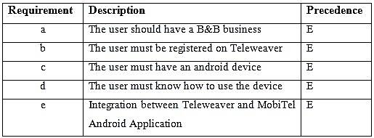**Table 4: Precedence and Criticality**

## External Interface Requirements (If known)

There are no current external interface requirements.

# Testing Provisions

We will have a rubric that the testers will use to benchmark the functionality of the application against user requirements. In addition, a user analysis and user testing will be conducted on at least three users from the Dwesa community who will test the application for ease of use and functionality. As soon as we create a functional component of the application, it will be presented to the users for testing. They will assist in gaining an understanding of their characteristics, preferences and opinions of the application throughout development. Users will be observed by interviewers to gain an understanding of how they interact with the current application. This will provide valuable insight into how we can improve the application to better suit their needs.

## Testing Rubric

### Testing Rubric Iteration 2, 13/08/2013:

|  |  |  |  |  |
| --- | --- | --- | --- | --- |
| **Item to Test** | **Test Description** | **Test Date** | **Responsibility** | **Comments** |
| Login | * Test Login Validations * Test logout | 10/08/2013 | Shana, Nonhlanhla | No Issues for this iteration. |
| Business Page | * Test all buttons * Test that edits save * Test validations * Test that only one image uploads * Test image upload from gallery and camera * Test removal of images * Test removal of business profiles | 10/08/2013 | Shana, Nonhlanhla | No Issues for this iteration. |
| Accommodation Page | * Test all buttons * Test that edits save * Test validations * Test that three images can upload * Test image upload from gallery and camera * Test removal of images * Test removal of accommodation profiles | 13/08/2013 | Ashley, Nicolan | No Issues for this iteration. |
| Room Page | * Test all buttons * Test that edits save * Test validations * Test that three images can upload * Test image upload from gallery and camera * Test removal of images * Test removal of room profiles | 13/08/2013 | SK, Lwando | No Issues for this iteration. |

### Testing Rubric Iteration 3, 08/09/2013:

|  |  |  |  |  |
| --- | --- | --- | --- | --- |
| **Item to Test** | **Test Description** | **Test Date** | **Responsibility** | **Comments** |
| Login | * Test Login Validations * Test logout | 08/09/2013 | Shana, Nonhlanhla | No Issues for this iteration. |
| Business Page | * Test all buttons * Test that edits save * Test validations * Test that only one image uploads * Test image upload from gallery and camera * Test removal of images * Test removal of business profiles | 08/09/2013 | Shana, Nonhlanhla | No Issues for this iteration. |
| Accommodation Page | * Test all buttons * Test that edits save * Test validations * Test that three images can upload * Test image upload from gallery and camera * Test removal of images * Test removal of accommodation profiles | 08/09/2013 | Ashley, Nicolan | No Issues for this iteration. |
| Room Page | * Test all buttons * Test that edits save * Test validations * Test that three images can upload * Test image upload from gallery and camera * Test removal of images * Test removal of room profiles | 08/09/2013 | SK, Lwando | No Issues for this iteration. |

### Testing Rubric Final, 27/10/2013:

|  |  |  |  |  |
| --- | --- | --- | --- | --- |
| **Item to Test** | **Test Description** | **Test Date** | **Responsibility** | **Comments** |
| Login | * Test Login Validations * Test logout | 24/10/2013 | Shana, Nonhlanhla | Reed House systems has not provided login authentication functionality as yet. The user is not registered on Teleweaver. |
| Business Page | * Test all buttons * Test that edits save * Test validations * Test that only one image uploads * Test image upload from gallery and camera * Test removal of images * Test removal of business profiles | 24/10/2013 | Shana, Nonhlanhla | No Issues identified. |
| Accommodation Page | * Test all buttons * Test that edits save * Test validations * Test that three images can upload * Test image upload from gallery and camera * Test removal of images * Test removal of accommodation profiles | 25/10/2013 | Ashley, Nicolan | Images were too large causing the program to crash. Images gave since been compressed. |
| Room Page | * Test all buttons * Test that edits save * Test validations * Test that three images can upload * Test image upload from gallery and camera * Test removal of images * Test removal of room profiles | 25/10/2013 | SK, Lwando | Room price field type has been incorrectly defined on the backend and hence data cannot be sent. The administrator has since been contacted to make adjustments |

### User testing: Iteration 3.

Date: 09 September 2013

Three users were selected for the user testing. They were required to follow three different scenarios (Add, Edit and Remove Business, Accommodation and Room details and images, respectively). The users are not familiar with smart phones and therefore found it difficult to navigate through the phone and understand what the application is supposed to do. From the user testing we found that the main issues were that the users were not sure how to add/edit business, accommodation and room information. A few of the users had an issue with the plus icon used to add a new business as they thought they could use the plus icon to populate the fields instead of selecting the field and then populating it.

These were some of the Frequently Asked Questions (FAQ):

* How do I login?
* How do I add my business?
* How do I fill in the information?
* How is accommodation separate from business?
* How do I add an image?

We found that the main issues was that the users were not familiar with smart phones and mobile applications and were therefore very nervous to try it out for themselves. We made changes that were necessary to take into consideration from the input received from the users during the User Testing. The designers will go into more detail of the prototypes in the Systems Design Specification Document.

# User training

## Goals and objectives

Luminus Solutions’ goal is to promote entrepreneurship and leverage the skills already available in the marginalized rural Dwesa Community. Luminous Solutions has recognized that the members of the Dwesa Community can be empowered through the use of a Mobile Application. This mobile application, MobiTel, will provide a tool to the members of the Dwesa community, who offer guest accommodation services, to advertise their business for free. By training the clients to use the application, we aim to ensure that they are well equipped and confident in using the mobile application once it is released. In addition, we aim to ensure that the mobile application, MobiTel, is being used to its full potential.

## Measure of Success

In order to establish whether or not our training was successful, we can examine the website to see if the information that is being displayed from the application has been filled in correctly. If the information is not correct we can revisit those specific clients to establish what difficulties they are having. In addition, we can deem the training a success if the client feels comfortable and confident in using the mobile application by asking the client to rate the training on a semantic differential scale.

## Benefits

The training will be beneficial, as it will ensure that the application is being used to its full potential and will help promote tourism in the Dwesa community and ultimately contribute towards development, competitiveness and productivity. The Training Evaluation Form will provide Luminus Solutions with insight into areas that can be improved when training is conducted for future projects.

## Costs

* Petrol costs to get to the clients
* Printing costs of each User Manual

## Limitations

Translation has been difficult as not all of the application terms have a direct translation into isiXhosa.

## Procedure

* Proposed date: 30 October 2013
* Facilitator: Lwando Sobekwa
* Venue: 17 D Joza, Grahamstown
* Duration: 2 Hours
* Consent: A consent form will be given to the participant(s) to participate in the training.
* Resources Used: Android Mobile Device.

For the rest of the users in the Dwesa Community, training will take place at the Siyakhula Living Labs to ensure that all the users fully understand the application and how to use it.